# India’s Agricultural Crop Production Analysis (1997-2021) INTRODUCTION:

**Overview:**

# This report delves into the captivating realm of India's agricultural cultivation, providing a comprehensive visual exploration of key aspects and trends in the agricultural sector. Through the visual representations, readers can gain valuable insights into crop production, seasonal variations, regional distribution, and overall production trends. These visualizations enable intuitive analysis, allowing stakeholders to uncover patterns, identify areas of growth or concern, and make data-driven decisions. By harnessing the power of Tableau, this report not only presents the data in a visually appealing manner but also provides an interactive experience for readers to explore the intricacies of India's agricultural cultivation. To Extract the Insights from the data and put the data in the form of visualizations, Dashboards and Story we employed Tableau tool. Purpose:

India is the second most populous county in the world. And to feed such a huge population, there is always a constant need for a supply of food. Therefore, there is a need for agriculture and a need for less dependency on the agricultural sector for the economy. Agricultural impacts society in many ways including: supporting live hood through food, habitat, and jobs, providing raw materials for food and other products; and building strong economic through trade.

# Problem Definition & Design Thinking Indeation & Brainstroming Map:

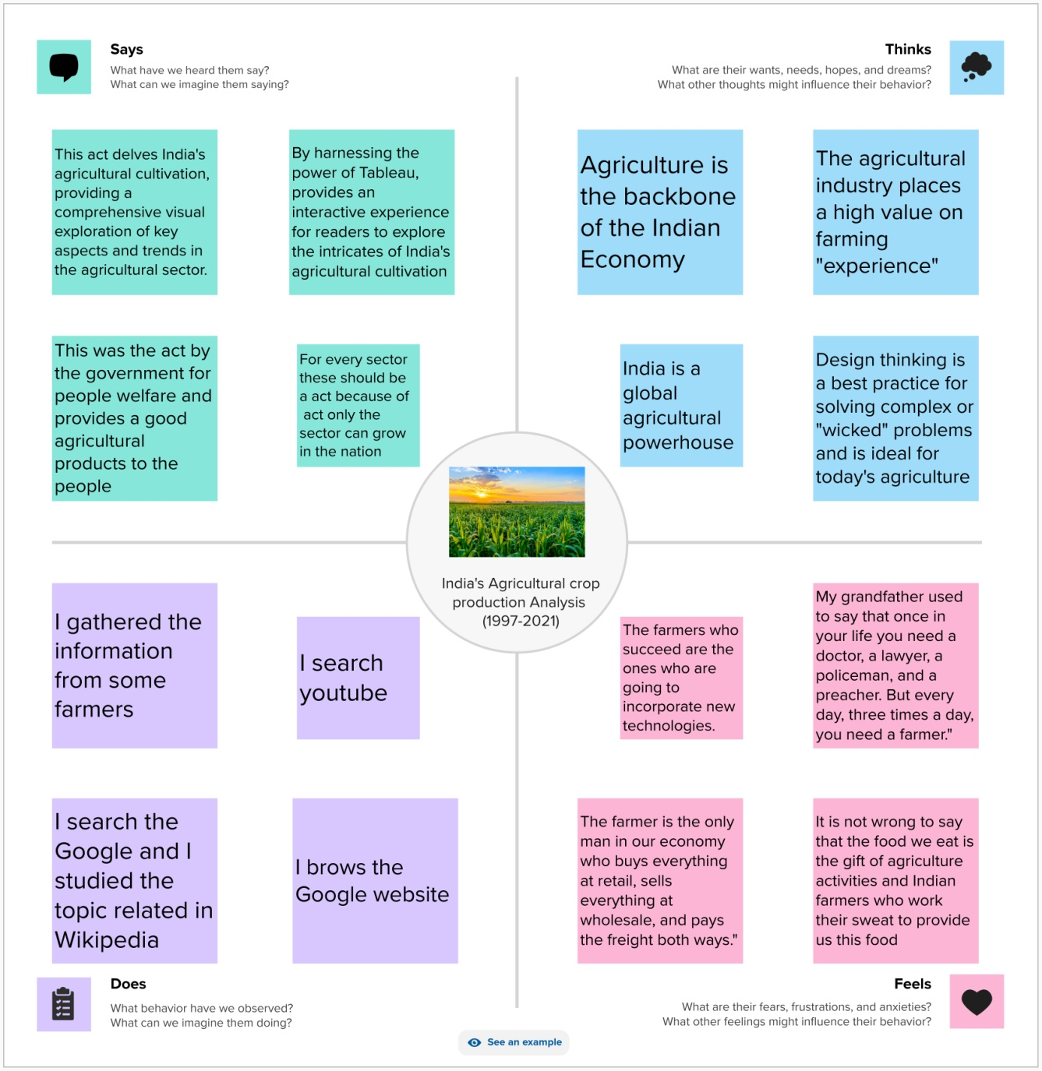 **Empathy Map :**

**RESULT:**

Sheet 1

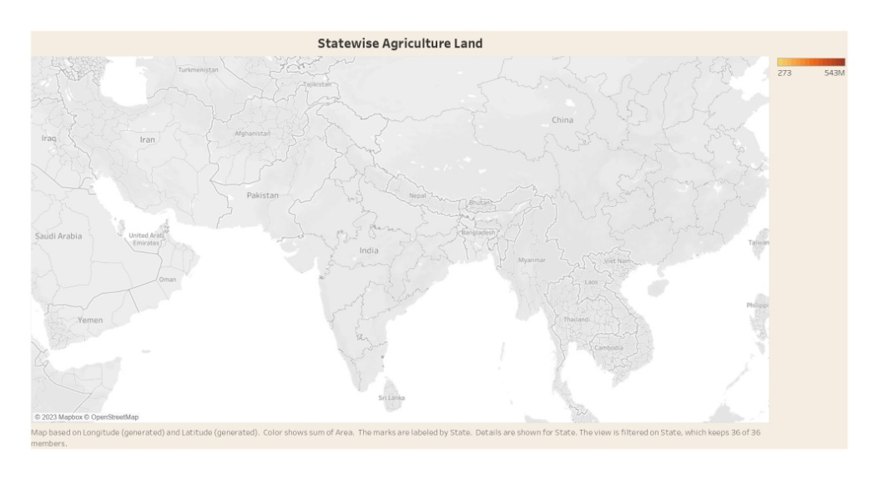

Sheet 2

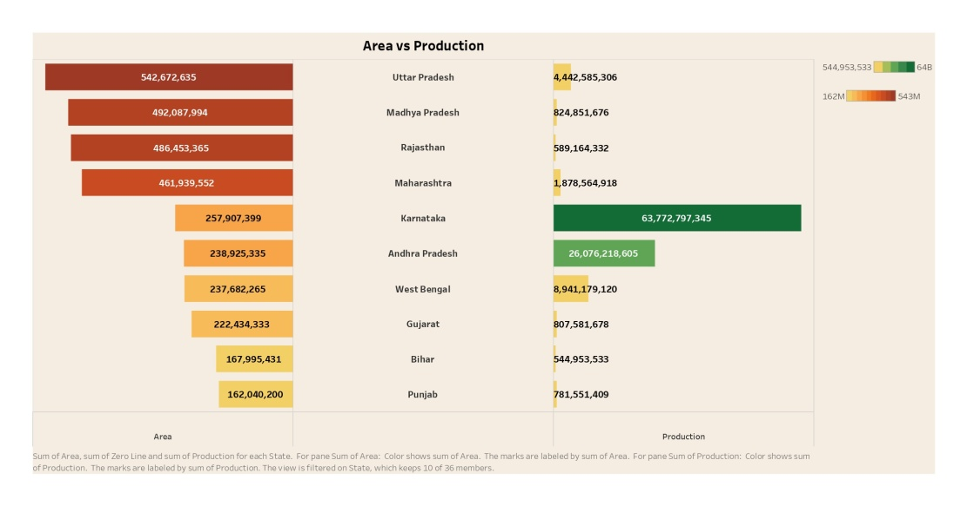

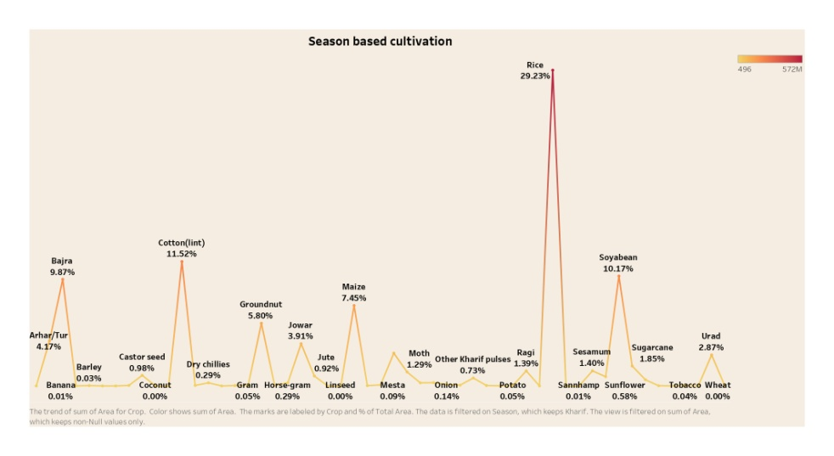Sheet 3

Sheet 4

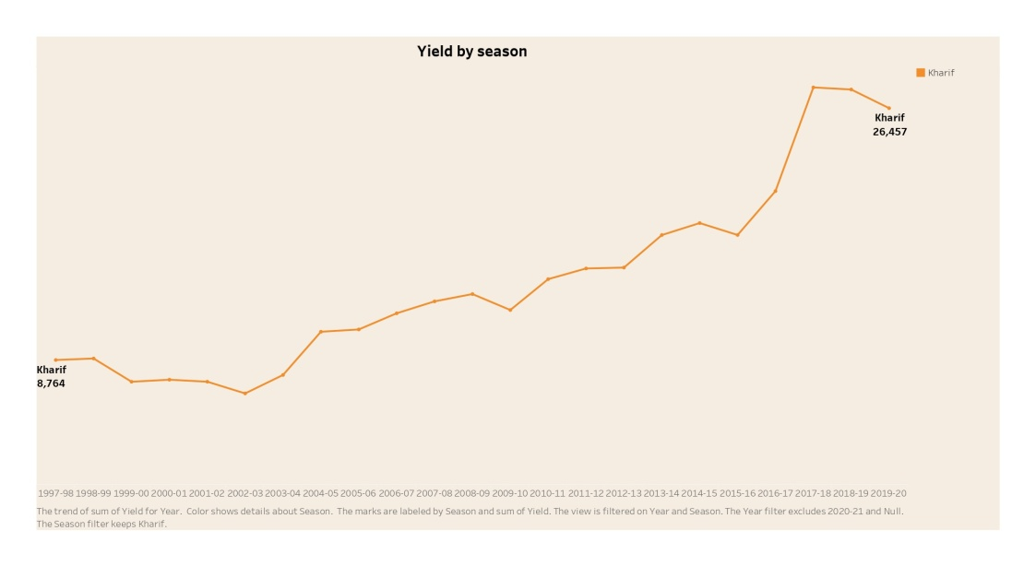

Sheet 5

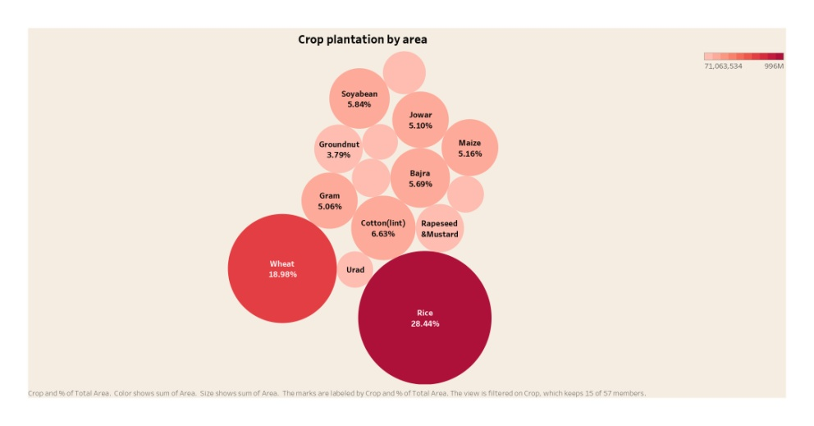

Sheet 6

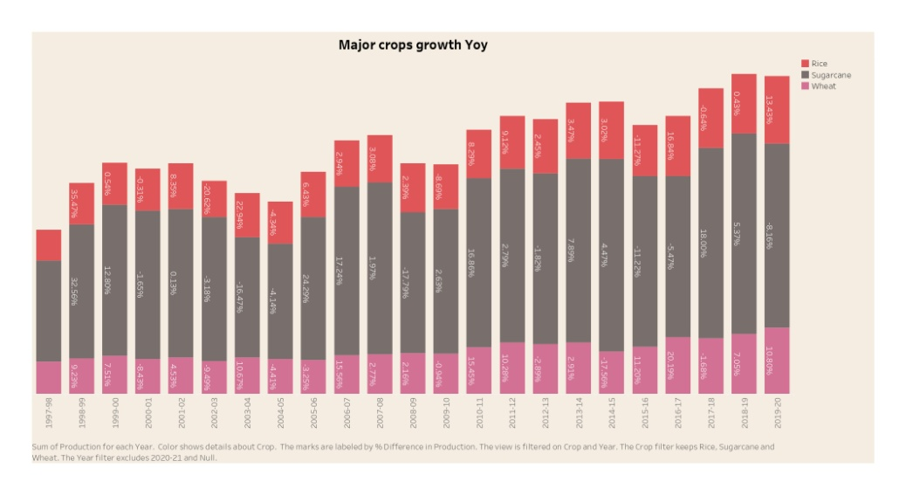

Sheet 7

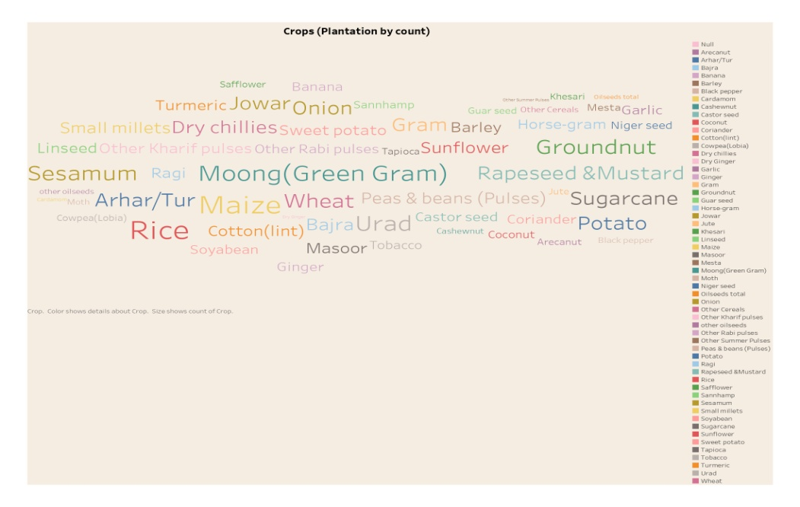

Sheet 8

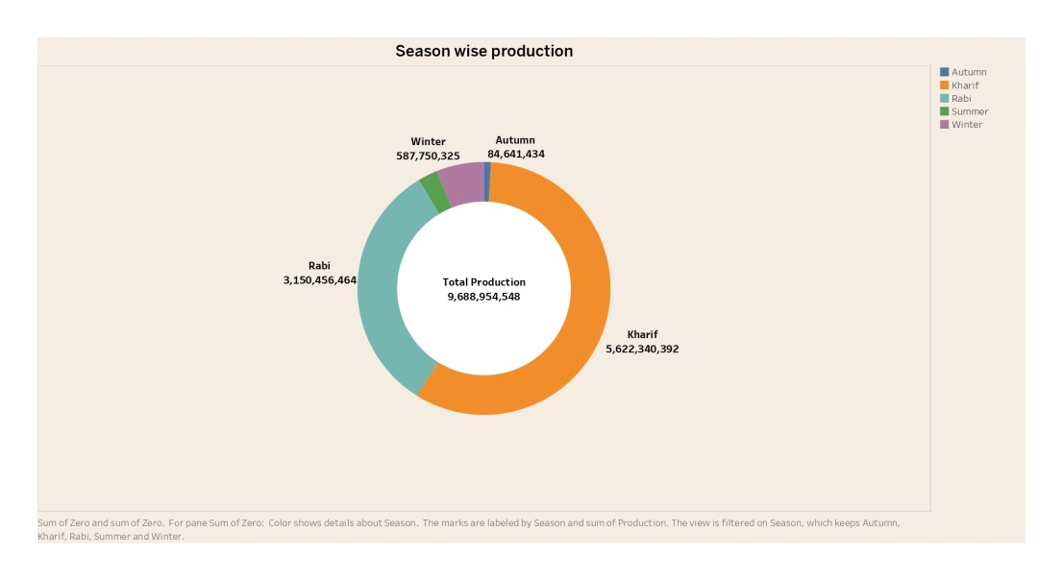

Dashboard 1

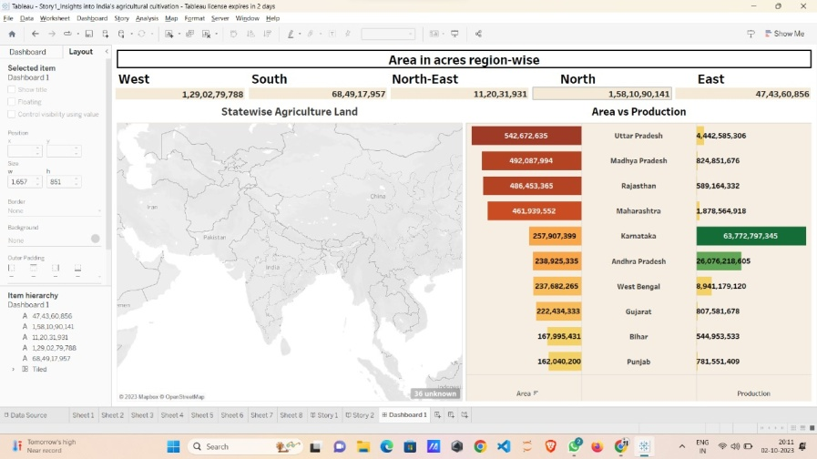

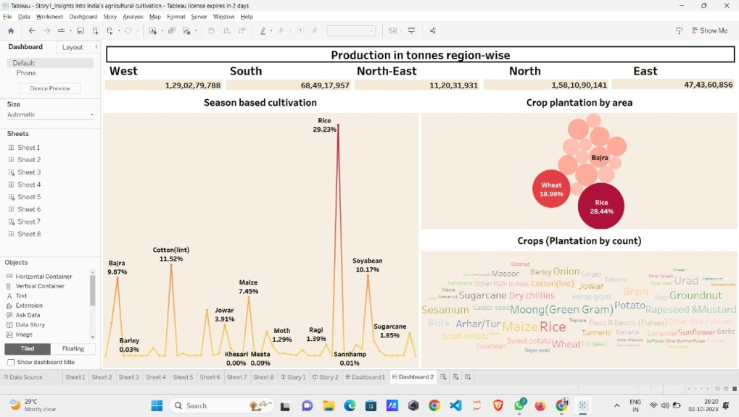Dashboard 2

Dashboard 3

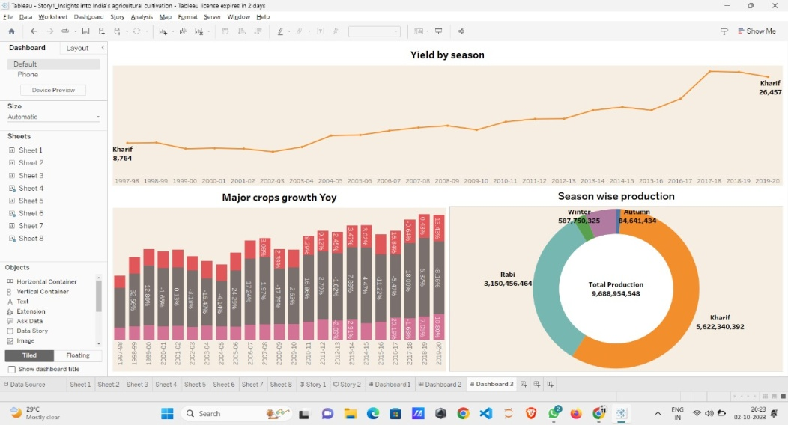

Story 1

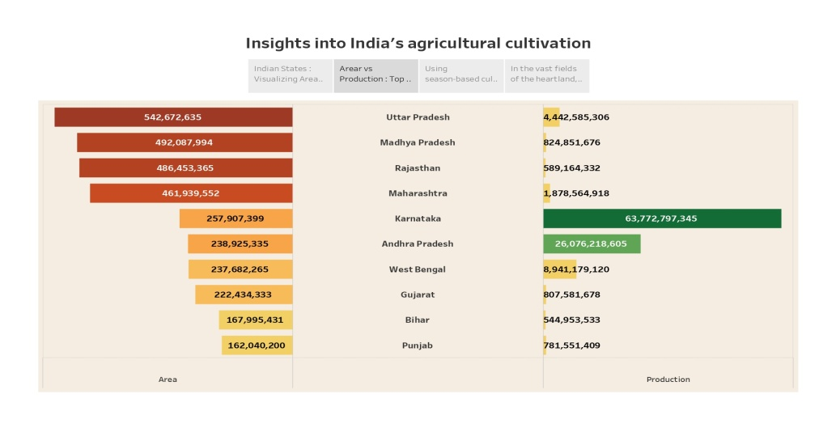

Story 2

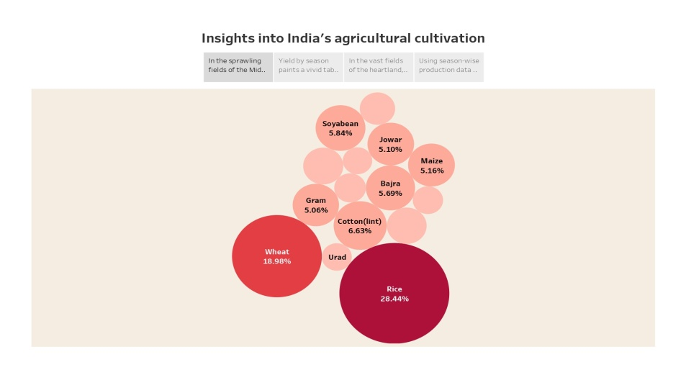

In this we analysis the trips by

* + 1. Bar graph showing the areas vs production of crop production.
    2. Bubble short showing insight into India's agricultural cultivation.
    3. Piechart showing the seasonal production of crops.
    4. Point grap showing the increase of production.
    5. Bar graph showing the yearwise crop production.
    6. Here peakchart showing the millets variation.
    7. Bubble short shows the millets production percentage.
    8. Maps shows the growth of the millets production.
    9. Highlights points showing the crops ( plantation by count).

# Advantage and Disadvantages: Advantage:

* **Data-Driven Policy Formulation**: Informed decision-making based on crop analysis aids in developing policies that enhance agricultural productivity, ensuring food security and rural livelihoods.
* **Risk Mitigation:** Analysis helps farmers anticipate and prepare for challenges, such as weather fluctuations, pests, and market dynamics, reducing vulnerability and crop losses.
* **Efficient Resource Allocation:** Improved analysis optimizes resource distribution, leading to better allocation of subsidies, irrigation, and credit, fostering sustainable and productive farming practices.

**Disadvantages:**

* **Data Accuracy Challenges:** Collection and reporting of data can be inconsistent, affecting the reliability of analysis, leading to suboptimal policy decisions and resource allocation.
* **Lack of Real-time Information:** Timely data updates can be lacking, causing delayed responses to emerging issues, potentially impacting crop yields and farmer income.
* **Limited Accessibility:** Smaller farmers may have limited access to analytical tools and expertise, potentially exacerbating inequalities and leaving them at a disadvantage in adopting data-driven farming practices.

# Applications:

* **Policy Formulation**: Utilize crop production analysis to develop and refine agricultural policies that ensure food security and promote sustainable farming practices.
* **Risk Management:** Implement data-driven risk mitigation strategies to help farmers prepare for climate-related challenges and market fluctuations.
* **Resource Allocation:** Optimize resource distribution by using analysis to allocate subsidies, credit, and infrastructure for efficient and equitable agricultural development.

# Conclusion:

India's agricultural crop production analysis is a vital tool for informed decision-making and resource management. While challenges exist, such as data accuracy and accessibility issues, the benefits of this analysis far outweigh the drawbacks.

**Future Scope:**

The future of agricultural crop production analysis in India holds promise. Advancements in technology, including satellite imaging and AI, can enhance data accuracy and real-time reporting. Furthermore, data accessibility can be improved through mobile applications, empowering even small-scale farmers. These developments will enable more precise policy formulation, efficient resource allocation, and enhanced risk management, contributing to the sustainable growth of India's agricultural sector.